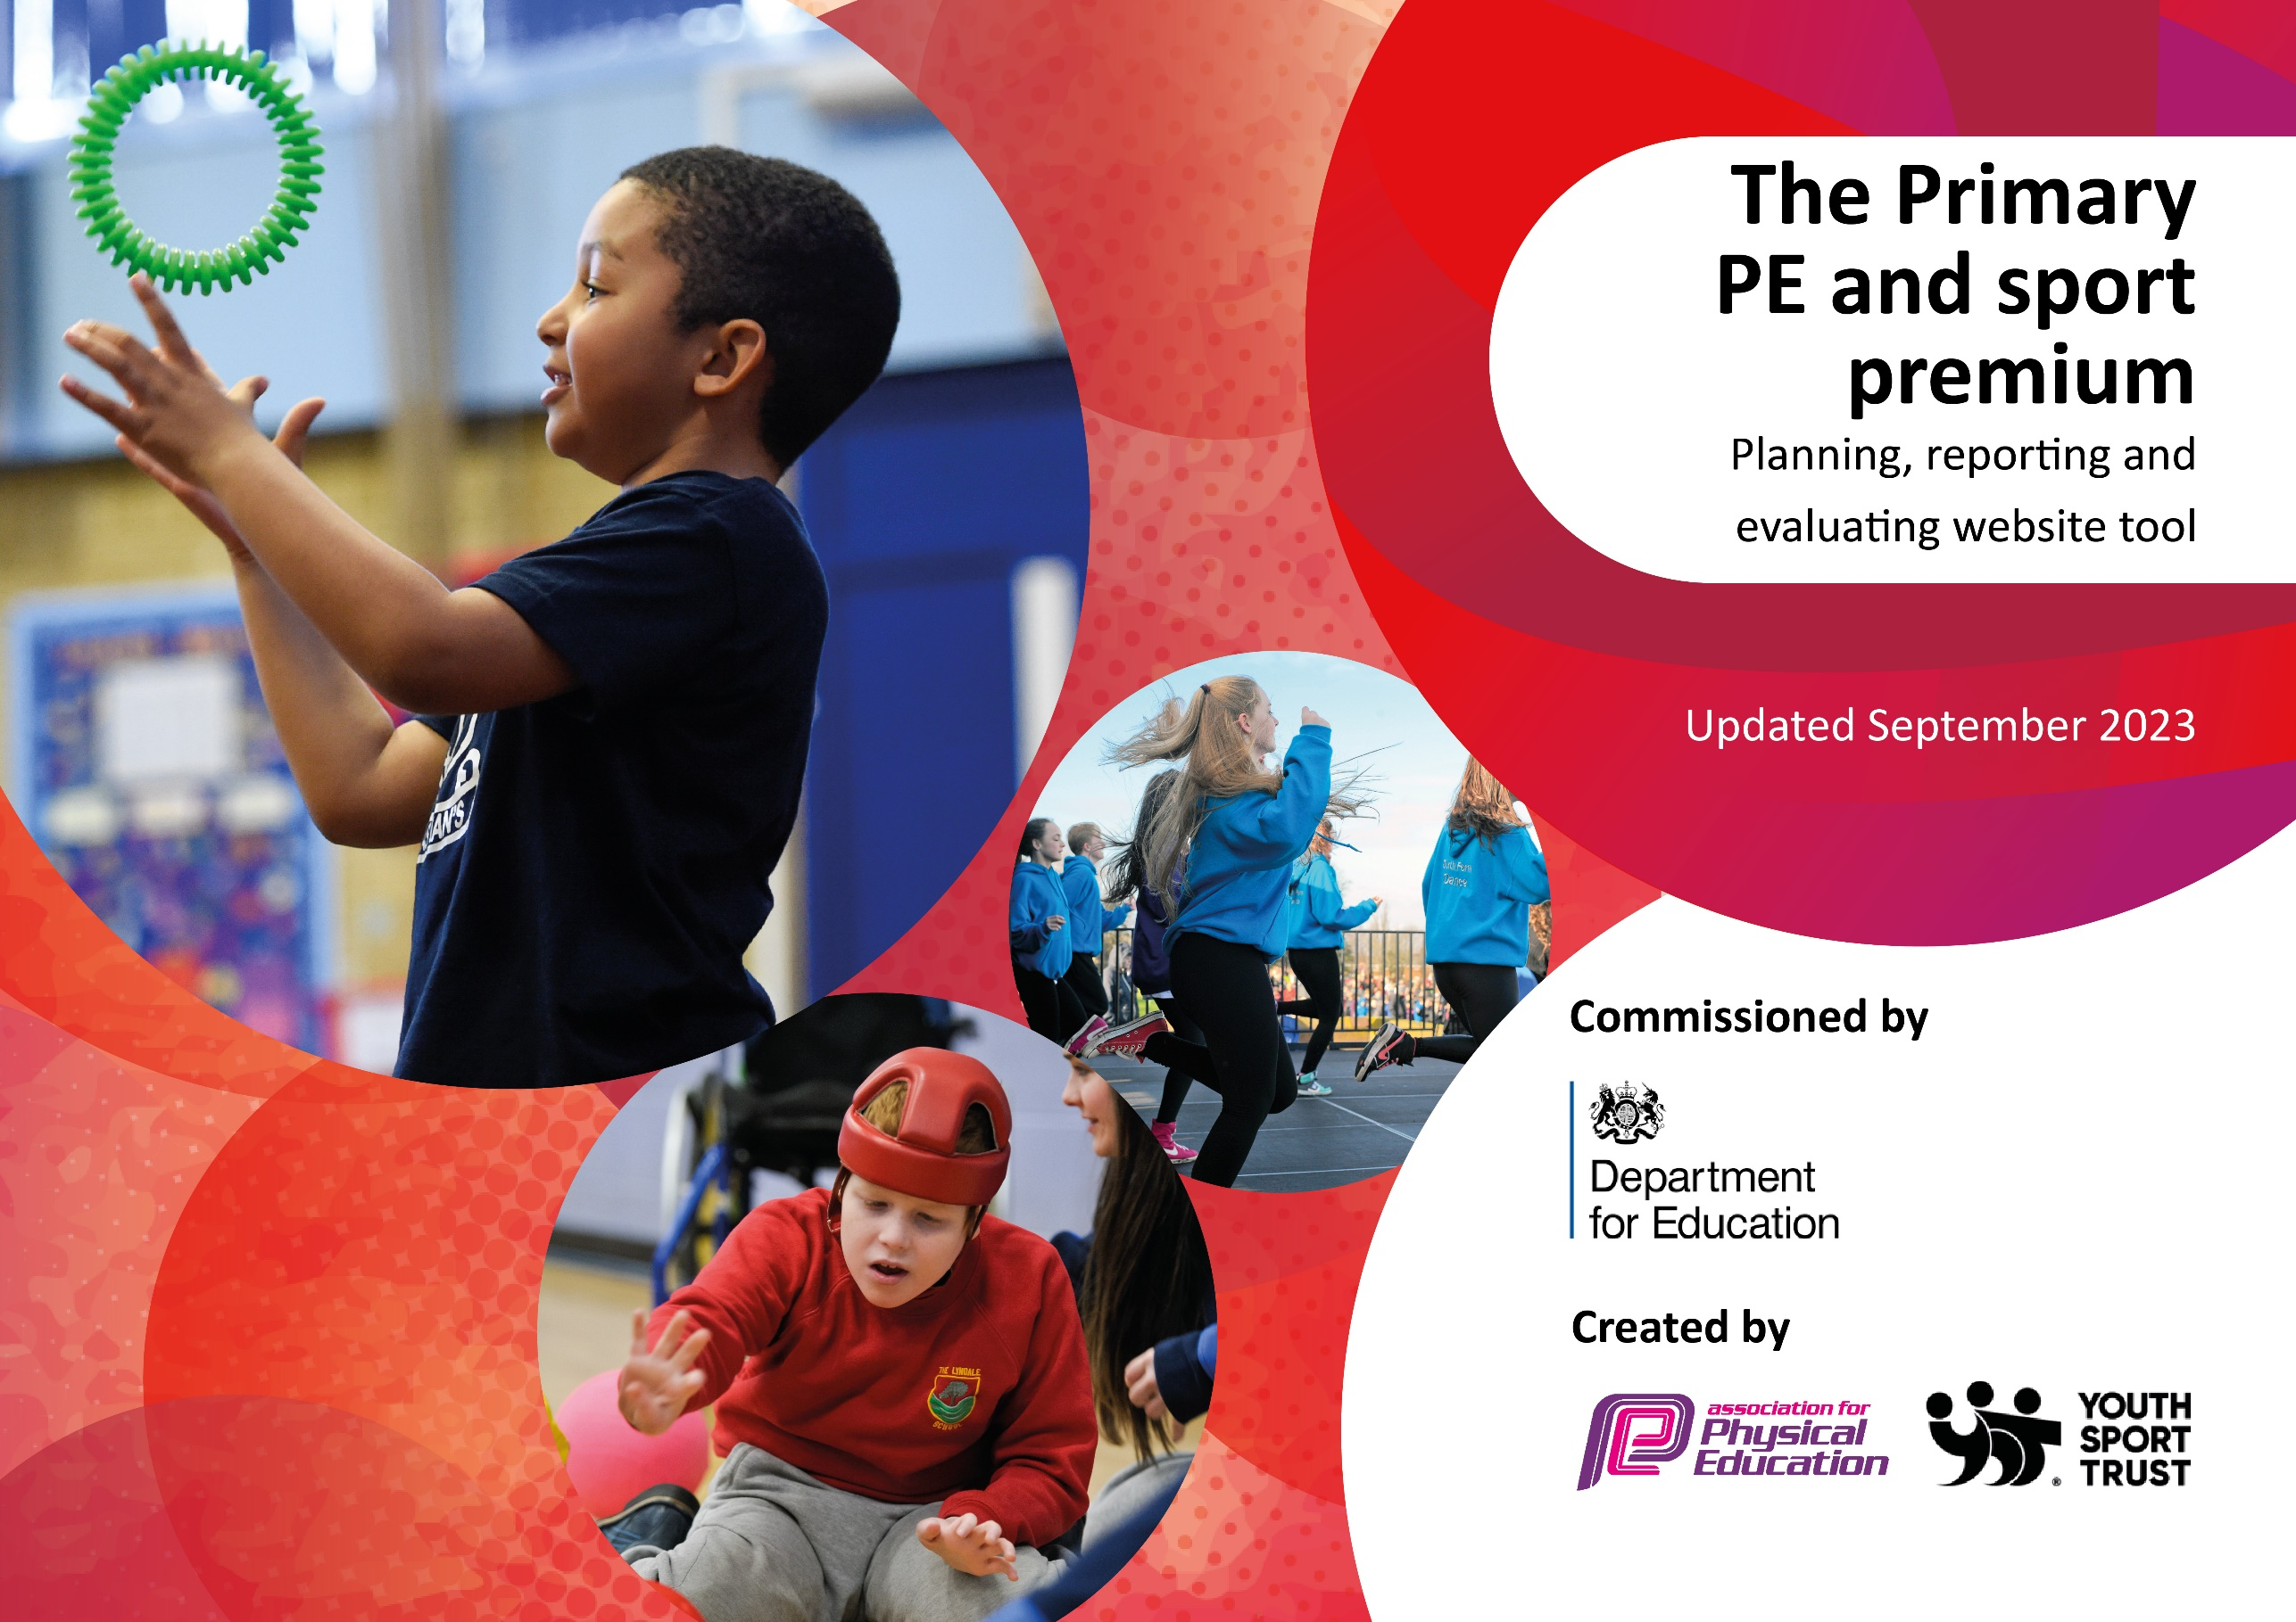

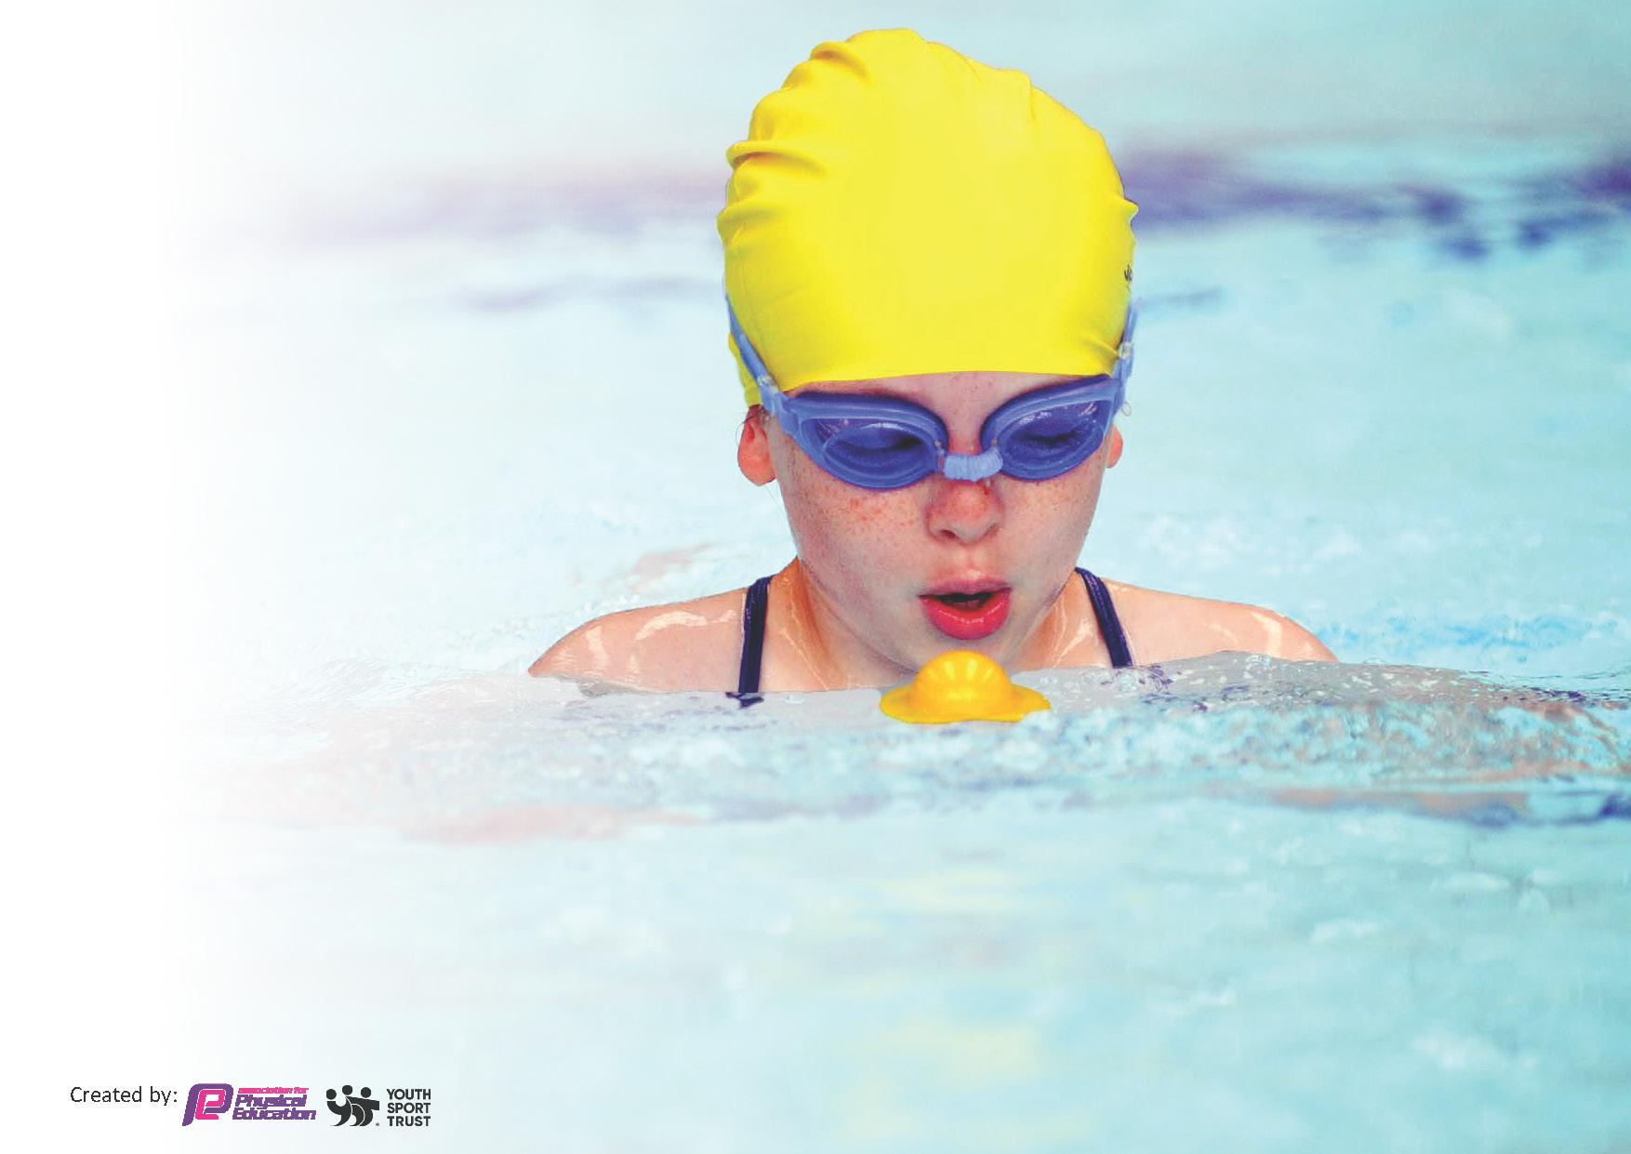
This template can be used for multiple purposes:
by:
- It enables schools to effectively plan their use of the Primary PE and sport premium
- It helps schools to meet the requirements (as set out in guidance) to publish information on their Primary PE and sport premium
- It will be an effective document to support Ofsted inspections enabling schools to evidence progress in Physical Education (PE) and evidence swimming attainment, which forms part of the PE National Curriculum. We would recommend schools consider
the Intent, Implementation and Impact of any spend, as examined within the Education Inspection Framework.

It is important that your grant is used effectively and based on school need.

Schools must use the funding to make additional and sustainable
improvements to the quality of the PE, School Sport and Physical Activity (PESSPA)
they offer. This means that you should use the Primary PE and sport premium to:

- Build capacity and capability within the school to ensure that improvements made now will benefit pupils joining the school in future years
- Develop or add to the PESSPA activities that your school already offers.

The Primary PE and sport premium should not be used to fund capital spend projects; the school’s core budget should fund these. Further detail on capital expenditure can be found in the updated Primary PE and sport premium guidance.

The Primary PE and sport premium guidance, outlines 5 key priorities that funding should be used towards. It is not

necessary that spending has to meet all the key priorities, you should select the priorities that you aim to use any funding towards.

Although completing this template is not a requirement for schools, schools are required to publish details of how they spend this funding. Schools must also outline what the impact this funding has had on pupils’ PE and sport participation and attainment and how any spending will be sustainable in the future. All funding must be spent by 31st July 2024.

The Department for Education has worked closely with the Association for Physical Education (afPE) and the Youth Sport Trust (YST) to develop this template and encourages schools to use it. This template is an effective way of meeting the reporting requirements of the Primary PE and sport premium.
Review of last year’s spend and key achievements (2022/2023)

We recommend you start by reflecting on the impact of current provision and reviewing your previous spend.

Activity/Action | Impact | Comments
CURRICULUM:  - Using resources from the ‘Get Set 4 PE’ scheme, the class teacher will deliver a 1 hour structured PE session per week.  A PSP coach will support the class teacher to deliver specific strands of PE, including gymnastics, dance and athletics.  This aim is to upskill teachers and improve the quality of teaching and learning in PE.  ACTIVE INITIATIVES:  - pupils to engage in regularly high quality active breaks throughout the day as part of the timetable.  - continue to promote the use of active lessons, active breaks, brain breaks and mindfulness through the continuation of the ‘Active Classrooms’ which was successfully implemented during the Summer term 2022.  This initiative enables pupils to record the number of minutes they have been active in the school day. The play leaders collect the total of active classroom minutes from each class weekly and announce the winner in celebration worship. The winning class will receive a certificate.  - pupils will be able to access resources/equipment at playtimes to encourage increased physical activity.  Each key stage will have a box of resources that can be taken outside at playtime.  New playleaders will be appointed from Y5 and 6, who will support physical activity at lunchtime across EYFS, KS1 and lower KS2.  Pupils will make use of the playground markings and the rocktagon,  New larger resources will be purchased that will further promote physical activity. This will include ‘ball funnel shoots’ and ‘large games’.  New bikes and scooters to be purchased to develop physical development in EYFS.  CLUBS:  - continue to run a range of clubs and use additional staff to open these up to a higher number of pupils, which will increase reduce the number of clubs being over-subscribed and avoiding the ‘first-come, first served’ method of allocating places.  introduce a range of clubs that will promote fitness and stamina but will also enhance skill development.  increase participation in inter-school festivals and competitions.  - one half day Forest School session per week (year R – 3) with termly swap weeks for pupils in Years 4,5,6.  Continue with the successful family sessions as an after-school provision to encourage pupils to engage with their parents in outdoor activities that they can then continue at home.  Key indicator 2: The profile of PESSPA being raised across the school as a tool for whole school improvement  TRIPS:  - provide opportunities for visits out and family events in school to further enhance opportunities to develop physical activity and wellbeing, including a Y6 residential visit to an outdoor activity centre.  - Proud Pupils’ access an external indoor or outdoor physical activity as an incentive/reward for being good role models (relating to behaviour, attendance, conduct, teaching and learning) at least once over the year.  WHOLE SCHOOL EVENTS:  - activities that promote, encourage and engage pupils  - festivals and intra/inter school competitions  - and encourage parental participation:  - sports day  - Invite parents to support their children at inter-school competitions.  - Weekly family club  Key indicator 3: Increased confidence, knowledge and skills of all staff in teaching PE and sport  - Pennine Sports Partnership (PSP) coaching staff to train, mentor, support and share good practice with teaching staff.  - Class teachers to use the new assessment system (part of ACE curriculum) to track attainment and progress of pupils.  - Robust assessment procedures in place.  - PLT to attend the Pennine Sports Partnership Day and network updates  SSCO to deliver regular team building activities to all staff.  Key indicator 4: Broader experience of a range of sports and activities offered to all pupils  PUPIL WELLBEING:  - implement wellbeing ambassadors to promote the use of mindfulness strategies throughout school.  - appoint pupil Befrienders to support pupil wellbeing at lunchtime.  - Little Seeds Yoga and Mindfulness Intervention to be delivered to all EY and Y1 pupils during the spring term with an after-school club for Years 2 and 3  SPECIALISED ACTIVITIES:  - Specialised coaches in school to enhance the curriculum by promoting cross-curricular links and physical development eg: Bollywood Dance, bikeability.  CLUBS:  - continue to run a range of clubs and use additional staff to open these up to a higher number of pupils, which will reduce the number of clubs being over-subscribed and avoiding the ‘first-come, first served’ method of allocating places.  - introduce a range of clubs that will promote fitness and stamina but will also enhance skill development.  Key indicator 5: Increased participation in competitive sport  - increase participation in inter-school festivals and competitions.  - Pupils from Y1-6 to attend various inter-school activities and competitions at external venues.  - Transport to take pupils to venues. | CURRICULUM:  Teaching staff/HLTAs using ‘Get Set 4 PE planning to delivery sessions on fundamental skills and games units.  Positive feedback received that the PE units are detailed and easy to follow.  Delivery of specific areas of Gymnastics, Dance and Athletics using PSP coaches.  Sessions used as CPD for teaching staff allowing CPD to cover more specialised elements of PE.  Actual Spend on PSP coaches-  Aut- £2275 + £2720 (from 21-22)  Spr- £1350  Sum- £2065 (estimate as no invoice received to date 17-7-23)  TOTAL: £8410  - Impact: All pupils are receiving a high-quality PE session in line with NC expectations.  Progress in PE (achievement against NC objectives):  EY: 87% (ELG physical development)  Year 1: 72%  Year 2: 93%  Year 3: %  Year 4: 76%  Year 5: 64%  Year 6: 70%  ACTIVE INITIATIVES:  Active Classroom initiative led by playleaders continued successfully.  Year groups participating in more active breaktimes through purchasing of more equipment.  Active brain breaks used effectively for individuals.  Play Leader representatives (Year 5/6) monitor the impact of increased activity with weekly presentations in Celebration Worship. The winning class receive a certificate and their success is published on a whole school display board.  Play Leaders from Y5 successfully appointed through application and interview process. They have been successful in their roles, supporting LKS2, KS1 and EY daily. Play Leaders supported an interschool Inclusion Event organised by PSP and hosted at CCA. 12-1-23  Actual Spend on equipment: £797.25  Following a change to leadership in Spring 2022, opportunities to enhance pupil opportunities in PE and physical activity were prioritised over purchasing larger resources to enhance playtimes.  These included participation in workshops, visits to local activity centres and links with local community groups that provide opportunities to participate in physical activities, such as boxing out of school.  Playtimes to become a priority for 2023-24 as part of the SDP.  Impact:  - More opportunity provided for structured physical activity throughout the day. Emphasis on Active Classroom led to greater pupil awareness of the need to be active as part of a whole school culture.  - This area will be further developed next year and will be the focus for Sports Premium spending in 2023-24.  - Access to regular physical activity supports regulation to enable pupils to focus on learning.  - Broadens opportunities to access experiences of physical activities beyond school environment through visits out and visitors in, including awareness and access to community activities.  - Enhance leadership skills and opportunities and support younger pupils to develop positive play skills.  - Develop confidence and skills of our young leaders.  - Opportunities created to develop this beyond school community through PSP Inclusion event.  CLUBS  Continued to offer a range of clubs throughout the year- at least 3 per week covering the age groups from Y1-6.  Increased participation in inter-school competitions and festivals from Y1-6, including events such as Strictly Pennine at Lawrence Batley Theatre.  Range of family sessions successfully implemented including cooking, gardening, board games, physical activities- regularly attended by 19 families.  Total spend on clubs: £3998.13  Total spend on resources: £644.60  Total spend on transport: £1484  Impact:  - This allows all pupils to access extra-curricular provision and enhance their skills development and opportunity to access high quality physical activity.  - Pupils and their families to acquire skills and ideas that can support positive family time outside the school day. This aims to strengthen relationships and support wellbeing.  TRIPS:  In March 2023, the Y6 pupils visited Kingswood in Penistone for a 3 day Residential trip.  In July 2023, all classes will visit Bradley Woods Activity Centre for an end of year trip.  Total cost on trips:  £388 (contribution to Y6 residential)  £2300 (Bradley Wood trips)  Impact:  - All pupils able to access opportunities to experience and participate in a range of physical activities.  WHOLE SCHOOL EVENTS:  School hosted a successful Sports Day event on 14-7-23, attended by pupils and staff from Y1-6 and a high number of parents. The event was organised into houses providing opportunity for pupils from KS1 and KS2 to work together.  This is the first sports day that has been hosted since 2019.  Impact:  - Cohesion across the whole school and parent community.  - Opportunity for all pupils to participate.  This year, a member of staff has held the responsibility of Club and Competitions co-ordinator. This has ensured a consistent commitment to accessing wider opportunities.  School have continued to strive to attend as many externally organised events as possible.  For 2023-24, the Club and Competitions Co-ordinator has secured free use of the minibus owned by the local secondary school. This will significantly reduce transport costs.  Total spend on attending interschool festivals/competitions, including transport: -see costs incurred in KI:1  Impact: School strive to attend as many external events as possible to provide wider opportunities for all pupils to participate in completion and to enhance their experiences.  As identified in KI1, all pupils received 1 hour high quality PE with fundamental skills/games units delivered by Class Teachers/HLTAS, using Get Set 4 PE scheme and the specialised areas of Gymnastics, Dance and Gymnastics delivered by a qualified coach from the Pennine Sports Partnership (PSP) and supported by the class teacher.  ACTUAL SPEND: Costs incurred in KI 1- alongside £1264 PSP membership  Impact: All children receiving the full breadth of the PE curriculum.  Class teachers made effective use of the Get Set 4 PE scheme to strengthen their confidence in teaching PE.  Class teachers use assessment tool to measure progress in PE.  Measure of progress and provide understanding of gaps in skill acquisition and support future planning.  EY: 87% (ELG physical development)  Year 1: 72%  Year 2: 93%  Year 3: %  Year 4: 76%  Year 5: 64%  Year 6: 70%  PE lead and Club/competition co-ordinator attended Pennine Sports Partnership Day in 21st September 2022  Impact:  - Updates regarding PE and participation in partnership events.  Link SSCO/PSP staff delivered play leader and lunchtime supervisor training.  Impact:  - All children participated in Active lunchtimes supported by lunchtime supervisors and Play Leaders. Continue to develop this moving in to next academic year.  PUPIL WELLBEING:  An ETA identified to deliver wellbeing interventions across school.  Mindfulness/calm zones continued to be used in classroom.  Wellbeing Ambassadors identified from Y4/5 and training delivered through MHST offer.  Pupils in Years EY, 1 accessed children’s yoga sessions delivered by Little seeds during the Spring term including a club for Y1 and 2.  ACTUAL SPEND: £630  Impact: Pupils developed strategies that they could use to enhance mindfulness strategies and support mental health and wellbeing. These will be further reinforced next academic year.  SPECIALISED ACTIVITIES:  Opportunities for visitors to school to deliver workshops to broaden pupil experiences and opportunities.  All pupils participated in a Bollywood Dance workshop (part of Diwali celebration) in October 2022.  Pupils in nursery and Reception participated in a Little Bikers Workshop.  Pupils in KS1 participated in a Scootering workshop.  ACTUAL SPEND: £1214  Impact:  - All pupils able to access opportunities to experience and participate in a range of physical activities.  Clubs are well established and well managed and participation in a range of festivals and inter-school competitions has increased. See KI 1 for costs incurred.  Impact:  - This allows all pupils to access extra-curricular provision and enhance their skills development.  Increased attendance at external events.  The allocation of a Clubs and Competitions co-ordinator has allowed a more consistent commitment to accessing wider opportunities.  Next year, school are able to use the minibus from the local secondary school which will reduce costs further.  Total Spend: Costs incurred in KI 1  Impact:  - School strive to attend as many external events as possible to provide wider opportunities for pupils to participate in completion and to enhance their experiences. Pupils give positive feedback and these experiences not only enhance their opportunities but also promote wellbeing. | In terms of curriculum PE, the key priority for next year is to continue to strengthen delivery of the PE curriculum through the use of the Get Set 4 PE as a resource to structure teaching of fundamental skills and games and utilising the CPD opportunities in the specialised areas of PE (Gymnastics,Dance and Athletics) throughout the year.  Teaching Staff have been provided with an overview of the year and a timetable.  Proposed SP spending: COST of PSP coaches.  Overall a key priority for next year is the development of Active playtimes and continuation of Active classrooms.  To ensure that pupils are participating in at least 30 minutes of physical activity each day, there will be a drive towards encouraging active lessons, regular energy breaks and a more adult-led structured approach to break times.  Evidence suggests that exercise has been shown to increase self-esteem, cognition and academic success, and decrease depression and anxiety in children. As a school, the number of pupils with a SEND primary need in SEMH is at 29% and our commitment to supporting the mental health and wellbeing of all our pupils will be further enhanced by ensuring that opportunities for high quality physical activity form a central part of our daily provision.  To support this, we aim to allocate Sports Premium spending to the following areas:  - Purchase equipment to enhance break time provision.  - Structure lunchtimes to create zones which incorporate active activities ensuring that pupils are engaged in purposeful play and high-quality physical activity. that provide a range of activities.  - Ongoing cycle of LTS training.  - Broaden the role of the pupil Play Leaders, ensuring that they are fulfilling their roles effectively.  Next year, we will continue to offer a range of clubs for all pupils, including externally organised activities  Proposed SP Spending:  - Club coaches and staffing  - access to external events.  Next year, we will continue to provide opportunities for visits out and family events in school to further enhance opportunities to develop physical activity and wellbeing.  All pupils, including ‘Proud Pupils’ access an external indoor or outdoor physical activity as an incentive/reward for being good role models (relating to behaviour, attendance, conduct, teaching and learning) at least once over the year.  Next year, emphasis will be placed on activities that promote, encourage and engage pupils and encourage parental participation:  - Invite parents to support their children at inter-school competitions.  - Invite parents in to watch performances linked to physical activity and school Sports Day.  - Provide opportunity for parents to engage with pupils in extra-curricular activities that promote wellbeing and healthy lifestyles.  - Continue ‘Family Club’.  Proposed SP spend:  COST of visits out to external settings that provide opportunity for wider physical activity and skill development.  Robust assessment procedures will be followed by teaching staff (both formative and summative) with baseline assessments conducted by PSP (TBC)  Staff meetings will be delivered by the link SSCO focusing on creating opportunities for physical activity throughout the school day, with regularly teambuilding activities and inter-school staff competitions throughout the year.  Link SSCO to deliver Lunchtime Supervisor training on 16-9-22.  Further opportunities for training around Active playtimes and Active Classroom activities to be provided throughout the year.  PE lead to attend PSP partnership day and network meetings, alongside member of staff allocated to the role of Club and Competitions co-ordinator will also attend updates and receive communication and support from Link SSCO.  Proposed Sports Premium Spending:  - membership of PSP  Pupil wellbeing continues to remain a priority and we aim to implement wellbeing ambassadors to promote the use of mindfulness strategies throughout school.  Role of wellbeing ambassadors to be established for 2023-24 as part of our commitment to supporting pupil mental health and wellbeing.  Proposed SP spending:  - COST of lanyards/caps to identify role.  As outlined in KI 1, we aim to continue to run a range of clubs and use additional staff to open these up to a higher number of pupils, which will increase reduce the number of clubs being over-subscribed and avoiding the ‘first-come, first served’ method of allocating places.  We aim to introduce a range of clubs that will promote fitness and stamina but will also enhance skill development.  We will continue links with community clubs (Empower) to broaden opportunities for pupils in the wider community.  We aim to increase participation in inter-school festivals and competitions.  Proposed SP spending:  - Club Coaches  - Staff to oversee club provision  - Transport to competitions.  Continue to build on participation in external events next academic year.

Key priorities and Planning
This planning template will allow schools to accurately plan their spending.

Action – what are you planning to do | Who does this action impact? | Key indicator to meet | Impacts and how sustainability will be achieved? | Cost linked to the action
Enhance assessment procedures and baseline assessments.  Promote physical activity throughout the school day.  Provide training for lunchtime supervisors.  Training for active playtime and active classroom activities.  Participation in PSP Partnership and Network Meetings.  Competitions and Clubs coordination  Strengthen the delivery of the PE curriculum and provide CPD opportunities in specialised areas of PE.  Promote daily physical activity, well-being, and a structured approach to break times.  Promote active lessons within the classroom to ensure pupils participate in at least 30 minutes of physical activity each day.  Offer a range of extracurricular activities and access to external events for all pupils.  Enhance opportunities for physical activity and wellbeing.  Recognise and reward positive behaviour and role models.  Promote parental engagement and participation.  Promote pupil wellbeing and mindfulness strategies.  Expand access to extra-curricular clubs.  Forest School to access different Forest Locations to enhance the pupils’ learning experiences in the outdoors.  Increase participation in inter-school festivals and competitions.  Monitoring and evaluation.  Pupils will continue to access opportunities for physical activities and sporting events outside of school so that pupils experience facilities available outside of the primary setting. | Teachers  HLTAs  Children  Children  Lunchtime Supervisors  Children  Lunchtime Supervisors  Children  PE Lead(s)  Teachers  Children  PE Lead(s)  Children  Teachers  HLTAs  Children  Children  Teachers  HLTAs  Support Staff  Children  Children  Children  Children  Parents/carers  Children  Children  Children  Children  Teachers  HLTAs  Parents/carers  Children  Children | Key indicator 1: Increased confidence, knowledge and skills of all staff in teaching PE and sport  Key indicator 2: The engagement of all pupils in regular physical activity – Chief Medical Officers guidelines recommend that primary school pupils undertake at least 30 minutes of physical activity a day in school  Key indicator 3: The profile of PESSPA being raised across the school as a tool for whole school improvement  Key indicator 4: Broader experience of a range of sports and activities offered to all pupils  Key indicator 5: Increased participation in competitive sport | Implement robust assessment procedures for both formative and summative assessments to track students' progress in physical education and physical activity.  Collaborate with PSP to conduct baseline assessments to establish the current physical fitness and activity levels of students.  Schedule staff meetings led by the link School Sports Coordinating Officer (SSCO) to focus on creating opportunities for physical activity throughout the school day.  Organise regular teambuilding activities and inter-school staff competitions throughout the year to encourage staff participation in physical activities.  Arrange for the Link SSCO to deliver Lunchtime Supervisor training to equip them with the skills and knowledge to facilitate active playtimes and ensure students are engaged in physical activities during break times.  Offer further opportunities for training on active playtimes and active classroom activities to school staff throughout the year to enhance the incorporation of physical activity into the daily routine.  PE lead(s) to attend PSP partnership day and network meetings to stay updated on best practices, resources, and developments in physical education and sports.  PE Lead(s) to act as the Club and Competitions Coordinators to oversee and manage extracurricular sports clubs, teams, and competitions within the school.  Ensure regular communication and support from the Link SSCO to facilitate effective coordination and participation.  Utilise the Get Set 4 PE resource to structure the teaching of fundamental skills and games in the PE curriculum.  Provide Continuous Professional Development (CPD) opportunities for teaching staff in Gymnastics, Dance, and Athletics.  Share an overview of the year and a timetable with teaching staff for effective planning.  Allocate Sports Premium (SP) funds for the employment of PSP coaches to support curriculum delivery.  Implement regular energy breaks during lessons.  Allocate SP funds to purchase equipment for break time provision  .  Restructure lunchtimes to create zones with purposeful play and high-quality physical activities.  Invest in the training of Lunchtime Supervisors (LTS) to facilitate structured break times.  Empower pupil Play Leaders to fulfil their roles effectively.  Monitor and evaluate the impact of these initiatives through data collection and feedback  Allocate SP funds for club coaches and staffing.  Ensure access to external events for students to broaden their sports experiences.  Regularly assess the participation and impact of extracurricular activities.  Gather feedback from students and parents regarding club offerings and external events.  Adjust club offerings and SP spending based on feedback and outcomes.  Forest School session per week (year R – 4).  Enhance opportunities for physical activity and wellbeing.  Continue to provide opportunities for visits out, including a Y6 residential visit to an outdoor activity centre, and family events in school to further enhance opportunities to develop physical activity and wellbeing.  Organise regular physical activity and wellbeing workshops for students to educate them on the importance of maintaining a healthy lifestyle.  Promote the use of outdoor spaces within the school premises for physical activities during break times.  Implement an incentive/reward system where all pupils, including 'Proud Pupils,' have the opportunity to access an external indoor or outdoor physical activity at least once over the year for demonstrating positive behaviour and being good role models.  Develop clear criteria and a tracking system for identifying students who qualify for these rewards.  Collaborate with teachers and parents to ensure a consistent approach to identifying and rewarding positive behaviour.  Invite parents to support their children at inter-school competitions by communicating event dates and encouraging attendance.  Organise physical activity events and school Sports Day, and actively invite parents to attend and cheer for their children.  Continue the 'Family Club' initiative, providing regular sessions where parents can engage in physical activities alongside their children to strengthen family bonds and promote health and wellbeing.  Establish a team of Wellbeing Ambassadors for the 2023-24 academic year, whose role will be to promote the use of mindfulness strategies throughout the school.  Provide the Wellbeing Ambassadors with lanyards/caps to identify their roles, making them easily recognizable to both staff and students.  Develop a comprehensive training program for Wellbeing Ambassadors, equipping them with the skills and knowledge necessary to effectively promote mindfulness and support the mental health and wellbeing of their peers.  Increase the number of extracurricular clubs offered to students to reduce over-subscription and move away from a 'first-come, first-served' method of allocating places.  Introduce a variety of clubs that focus on promoting fitness, stamina, and skill development to cater to a wider range of student interests and abilities.  Employ Club Coaches and additional staff to oversee club provision, ensuring that clubs are well-organised, safe, and engaging for students.  Foster and maintain strong links with community clubs, such as Empower, to provide students with opportunities to participate in activities beyond the school setting.  Specialised coaches in school to enhance the curriculum by promoting cross-curricular links and physical development, e.g: Bollywood Dance, ‘bikeability’.  Allocate budget for transportation to inter-school festivals and competitions, ensuring that students have the necessary means to attend these events.  Encourage and support teachers to take on the role of coaches and mentors for students participating in inter-school competitions.  Actively promote and publicise inter-school festivals and competitions to boost student interest and participation.  Establish a clear communication strategy to inform parents and guardians about the benefits of inter-school competitions and seek their support in encouraging their children's participation.  Implement regular assessments to evaluate the impact of these initiatives on pupil wellbeing, club participation, and success in inter-school competitions.  Analyse the feedback from students, parents, and staff to make necessary adjustments and improvements to the action plan.  Share the outcomes and successes of the Sports Premium initiatives with the school community to foster continued support and involvement.  Increase participation in inter-school festivals and competitions.  Pupils from Y1-6 to attend various inter-school activities and competitions at external venues.  Transport to take pupils to venues. | See KI: 2  PSP membership- annual fee:  £1500  £5000  No cost incurred  £500  £2000  £2000 (transport to venues)  £3700  £630  £2000  Transport through NHTS.  Cost of petrol. (Autumn)  Hiring of coaches (policy change) from Spring 1  Costs incurred in KI:1

Key achievements 2023-2024
This template will be completed at the end of the academic year and will showcase the key achievements schools have made with their Primary PE and sport premium spending.

Activity/Action | Impact | Comments
Key indicator 1: Increased confidence, knowledge and skills of all staff in teaching PE and sport  Enhance assessment procedures and baseline assessments.  Promote physical activity throughout the school day.  Provide training for lunchtime supervisors.  Training for active playtime and active classroom activities.  Participation in PSP Partnership and Network Meetings.  Competitions and Clubs coordination  Key indicator 2: The engagement of all pupils in regular physical activity – Chief Medical Officers guidelines recommend that primary school pupils undertake at least 30 minutes of physical activity a day in school  Strengthen the delivery of the PE curriculum and provide CPD opportunities in specialised areas of PE.  Promote daily physical activity, well-being, and a structured approach to break times.  Promote active lessons within the classroom to ensure pupils participate in at least 30 minutes of physical activity each day.  Offer a range of extracurricular activities and access to external events for all pupils.  Key indicator 3: The profile of PESSPA being raised across the school as a tool for whole school improvement  Enhance opportunities for physical activity and wellbeing.  Recognise and reward positive behaviour and role models.  Promote parental engagement and participation.  Key indicator 4: Broader experience of a range of sports and activities offered to all pupils  Promote pupil wellbeing and mindfulness strategies.  Expand access to extra-curricular clubs.  Forest School to access different Forest Locations to enhance the pupils’ learning experiences in the outdoors.  Increase participation in inter-school festivals and competitions.  Key indicator 5: Increased participation in competitive sport  Pupils will continue to access opportunities for physical activities and sporting events outside of school so that pupils experience facilities available outside of the primary setting. | Informal baselines carried out at the start of the units delivered by PSP. Areas of development identified. PSP membership £1264  Use of Playleaders has been successful, supporting LKS2, KS1 and EY daily. Play Leaders supported an interschool Inclusion Event organised by PSP and hosted at CCA. High Vis Jackets £173.23  PSP delivered training for lunchtime supervisors; there has been a slight increase/improvement in participation and engagement.  Not undertaken.  Meeting held in September. Activities shared with staff.  4-5 clubs held per week which have been well attended. PSP events booked have all been attended. Further tournaments have started to be planned via the Trust. Regular communication and support from the Link SSCO who helped facilitate effective coordination and participation  Empower Coaching Autumn £1400 Spring £1250 Summer £600  Overtime for after-school clubs £1524.65  Taxis and coaches to competitions/events £785  Hockey coaching kit £179.98  Autumn 2 coaches £950  Summer 1 Boxing £800  Spring 2 coaching £760  Summer 2 coaching £1330  Adults in each class now observe and encouraged to actively participate in PSP sessions (every other half-term) as part of CPD. All staff aware of CPD resources on GetSet4PE website.  Sports equipment £2,047.28  Little Bikers (KS1) £272.50  A timetable was set up in the upper phase for Year 5 and Year 6 girls and boys football to encourage the other children to participate in other activities.  This has not been followed through as initially hoped, but will continue to be an area for development.  There have been a range of activities provided in after school clubs across the different age ranges, with an average of 4 clubs per week. 1-2 led by the Forest School Practitioners; 1 led by PSP; and 1-2 led by an ex-pupil.  Numerous competitions and events held, alongside the range of after school clubs has promoted physical activity. Y6 had a residential visit to an outdoor activity centre in November. Links made with Science and physical and mental health, including through the use of a visit from a Paralympian in March who held circuit sessions for each class and delivered an inspiring assembly.  KS2 visit to Filey beach in July; range of sports (boules, rounders, football, ultimate frisbee, athletics) played on rotation alongside mindfulness activities.  Kingswood contribution £594  Filey coaches £1800  Frisbees £19.17  Mainly through PSP, we have started to develop more child-led demonstrations and ‘WAGOLLs’. House points continued to be used to recognize success and effort, and an increase in recognition in Celebration Worships on Fridays. Furthermore, we have used the ‘Proud Pupil’ system to identify children to attend specific events.  Parents and carers invited to Sports Day in July to promote support, participation and enjoyment.  Sports Day medals £134.97  Fitness and well-being units delivered, including yoga and pilates throughout the school. Active brain breaks used effectively for individuals. Play leaders and well-being leaders used effectively to support during break and lunchtimes.  As covered in Key Indicator 2.  Forest School has mainly used the usual school grounds, but Years 4, 5 and 6 have been able to access this year. Year 6 also had Forest School experiences as part of their residential.  We have continued with a similar program to last year, but have attended extra events and festivals such as the Trusts football tournaments and ‘This Girl Can’. All events have been (well) attended and in many cases over-subscribed.  Football kit £1659  As mentioned in Key Indicator 2. As a result of one of our after-school clubs, we have seen an increase in the number of children attending the local boxing gym. | Late invoices from 2022/23:  Coaches for Dance Festival £2110  Coach to Dance Festival £380  Dance Festival entry £200  New assessment system to be implemented by school.  This is an area that needs to be developed further next year.  The range of clubs has worked well across each phase.  EY: 90% (ELG physical development)  Year 1: 83%  Year 2: 72%  Year 3: 93%  Year 4: 63%  Year 5: 73%  Year 6: 81%  Increase in percentages in each class accessing ‘ARE’ with the exception of Years 4 and 5.  This needs to be further developed next year as we have seen an increase in the other equipment being utilised.  We have provided after school clubs for athletics, gymnastics, dance, football, multi-skills, cricket, rounders, boxing and rounders.  A next step is to link PSHE and vocabulary with our PE vocabulary and lessons.  This needs to be further developed next year through the use of identified PE leaders.  As Key Indicator 3.  An area for next year could be to further help parents identify local clubs and events for during evenings and weekends, alongside the usual flyers distributed for football ‘camps’ during the holidays.  23/24 budget £17,670  22/23 carry forward £3425  Total £21095  Total spent/committed £20637.31  Total remaining £457.69

Swimming Data
Meeting National Curriculum requirements for swimming and water safety.
Priority should always be given to ensuring that pupils can perform safe self-rescue even if they do not fully meet the first two requirements of the National Curriculum programme of study

Question | Stats: | Further context  Relative to local challenges
What percentage of your current Year 6 cohort can swim competently, confidently and proficiently over a distance of at least 25 metres? | 62% | Use this text box to give further context behind the percentage.  e.g., 30% - we are struggling to get pool space due to our local pool closing so we have had to use a much smaller local school pool. We have had to limit the number of pupils attending swimming lessons during one term which means some pupils have attended fewer swimming lessons than others.
What percentage of your current Year 6 cohort can use a range of strokes effectively [for example, front crawl, backstroke, and breaststroke]? | 14% | Use this text box to give further context behind the percentage.  e.g., Even though your pupils may swim in another year please report on their attainment on leaving primary school at the end of the summer term 2024

What percentage of your current Year 6 cohort are able to perform safe self-rescue in different water-based situations? | 17% | Use this text box to give further context behind the percentage.
If your schools swimming data is below national expectation, you can choose to use the Primary PE and sport premium to provide additional top-up sessions for those pupils that did not meet National Curriculum  requirements after the completion of core lessons. Have you done this? | Yes/No
Have you provided CPD to improve the knowledge and confidence of staff to be able to teach swimming and water safety? | Yes/No | KAL provided the venue and lessons.

Signed off by:

Executive Head Teacher: | Nikki Summers
Subject Leader or the individual responsible for the Primary PE and sport premium: | Rob Dawson. Associate Leader.
Governor: | Julian Kennett. Chair of Governors.
Date: | July 2024

